Answer to Questions for Mr. George Diehl
Aviation Chapter Mini PDI May 12, 2022

Link to the slides for Mr. George Diehl: Shared Folder on OneDrive

Beth Jankowski :
George, I have One Drive to back up my c drive. Why do I have to put my email address every time I open a file on my C;Drive? Why does, at times, I can't get those files out of "Read Only" status
George:
Beth, this is likely an OneDrive login prompt that is being triggered because your Office desktop apps (i.e. Outlook, Excel, PowerPoint, and Word) are logged in under the wrong account by default. Slide 12 of the slides I presented talks about this or you can get more detailed instructions in the “”Office and OneDrive Account.pptx” slides in the DAF365 folder found in my Shared Folder on OneDrive. Once signed into Office with your “@us.af.mil” account, your desktop apps should stop prompting you to log into OneDrive.
David Porter:
Comment: I can't leave OneDrive running during workday as it cripples the performance of my system. Instead I open and let it sync at the end of the business day or week.
Everything on the desktop is scanned on startup. So if you literally have 50 folders with tons of junk in them, or gigs of movies on the desktop, then it can degrade performance and on ear startup time.
George:
This is a good suggestion for compensating for low bandwidth or computer hardware resources. Right-clicking on your OneDrive icon in the lower-right corner of your screen should show a few Pause Syncing options as well. Using the pause option may help lower the risk of data loss due to forgetting to turn OneDrive on at the end of the day.
Amanda Murphy:
Do the files carry over when we move orgs too since its CAC enabled?
George:
Your OneDrive files are associated with your “@us.af.mil” Office account. So as long as you are staying within the Air Force tenant, your files will stay on the cloud and remain accessible as you move orgs. I am not as familiar with the other DoD tenants so you may need to verify your file retention if your move results in your email changing (e.g., “@mail.mil” or “spaceforce.mil”). If I come across an answer for that scenario, I will try to provide an update.
Belinda Elsherif:
Does One drive save folders separately when logging in on different VPN networks?
George:
No. OneDrive is tied to your “@us.af.mil” Office account. Our VPN options are simply different paths to the internet and network where OneDrive is located. You should see the same files regardless of USAF VPN, JRSS VPN, or off VPN via web app.
Scott Wilson:
Sorry for sharing a long note... When we submit a MIPR upload package to DFAS via E-File Room, the E-File Room cannot accept the "-" character. Since OneDrive file structure includes a "-" (C:\Users\\OneDrive - United States Air Force\Documents), these upload packages cannot be saved within OneDrive and I've had to save them locally in my pictures folder. Is it possible to remove the dash from the One Drive Folder title? If not, FYSA that upload packages must be saved locally.
George:
I do not believe the OneDrive folder name can be changed. The name is likely controlled by some sort of group or network policy that is triggered when our accounts are created. A change to that seems unlikely in my opinion. Good suggestion for other users of the DFAS E-File Room, save your upload packages to a folder OneDrive will not monitor. For reference, OneDrive monitors the Desktop, Documents, or Pictures folders only.
Cindy Willis:
I have a file saved on my hard drive and the same file on the one drive. When I update the file on my hard drive, it does not update the file on the one drive even though it say its updated.
George:
This sounds like a situation where either OneDrive is not fully connected/setup or you may have the file saved in a location which OneDrive is not monitoring. If one file is not syncing, then it is likely others are not syncing also. Unfortunately, I would need more information on the specific file. Feel free to contact me and we can try to troubleshoot.
Ann Franklin:
Is there a search feature in the Teams chat to look for topics in previous chats? When we used Skype, Outlook could record all conversations.....a keyword search was ideal for finding conversations as a way of keeping "notes."
George:
All chat discussions are saved indefinitely unless manually deleted. Teams has a search bar across the top of window. This search bar can be sued to search messages. Just type your search term in the bar and press enter. From there, you can view the search results by Messages, People, or Files as shown below. You can also apply an advanced filter using the filter button circled below. More details on this capability can be found here.
John Campanella
How can other folders be added to OneDrive--that is, in addition to Desktop, Documents, Pictures?
George:
As far as I can tell, we do not have the ability to add more files to what OneDrive syncs. I believe this setting is controlled by group or network policy. You can exclude folders but that is the extent of our control.
Jamie Iaquinta
We have the new version of Share Point. I am having an issue where people are going into a spread sheet and updating it and writing over what other people have done. How do I keep this from happening?
George:
If the users are simply inputting information into the spreadsheet, I would recommend that the users “open in browser” instead of “open in app” when accessing the file. This can be done by selecting the file and using the Open dropdown, as shown below, instead of clicking on the file name. Until our Office desktop apps are upgraded to Office 365, multi-user editing at the same time in Excel will work the best in the browser app.
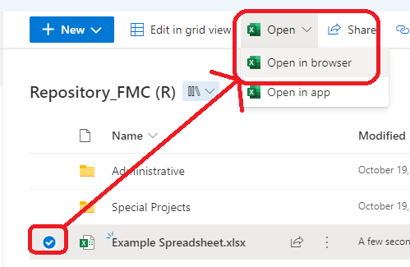
Jennifer Harphant
Is there an easy way to move our IE bookmarks to Chrome or Edge?
George:
Daniel Long provided some steps below so here are some pictures. In Edge, click on the star icon, then the ellipsis for more options, then select Import Favorites. An import browser data window will open where you can select IE and Favorites or Bookmarks.
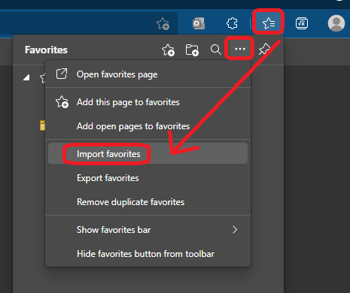 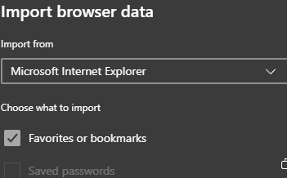
Since Edge uses Chrome’s engine, the process is almost the same in Chrome.
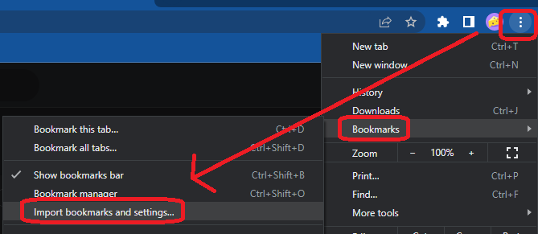
Daniel Long:
For Chrome, to import bookmarks from most browsers, like Firefox, Internet Explorer, and Safari:
1) At the top right in Chrome, click More (the three dots).
2) Select Bookmarks. Import Bookmarks and Settings.
3) Select the program that contains the bookmarks you'd like to import.
4) Click Import, then click Done.
George:
Thanks for the help David.
Kristen Leopold:
What symbol are we supposed to have- the cloud? the check?
George:
In short, any of the ones below are good:
Which one specifically will depend on what you want. The cloud means that it is available on the cloud and your computer will download it when you open it. The check with the white fill means the file has been downloaded and is synced to the cloud. The check with the green fill means that the file has been flagged as “Always keep on this device” and is downloaded automatically whether you open it or not. More details can be found on Slide 18 of the slides I presented.
Gregory Carthen:
How do you tag a folder to not sync?
George:
Click on the OneDrive icon in the lower-right corner of your screen then select the gear/cog icon to open the settings. Then click “Choose folders” for your “OneDrive – United States Air Force” in the Account tab.
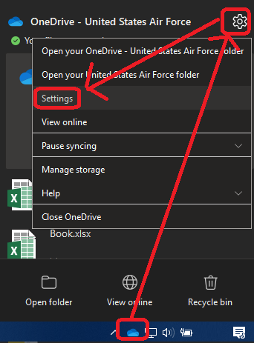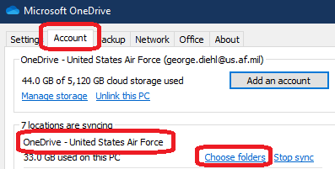

Jennifer Harphant
Best way to delete old chats?
George:
I have received this question many times. Teams does not have an option to bulk delete chat messages at this time. You can manually delete messages one at a time as shown in the picture below. Persistent chat is a key feature of Teams and I would not expect bulk deletion capability anytime soon. This article shows how you can hide chats if you are simply trying to clean up your screen.
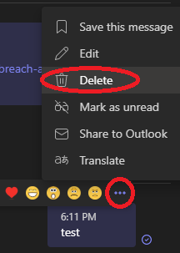
Jennifer Ruwaldt
When changing MS Office from @mil to @us.af.mil will documents created under @mil be lost?
George:
No. This action is simply changing the Office account that your desktop apps are logged in with to the one that matches your OneDrive account. Doing this just enables your Office desktop apps to communicate with OneDrive and DAF365 using the correct Office account which is why the email prompts should stop when you do this. All of your files and emails are untouched by this account change.
Chuck Van Dine:
- Is there a solution to view encrypted emails without receiving the follow message in DAF365 Outlook, “S/MIME isn't supported in this view. To view this message in a new window, click here.” This issue use to be much worse for me in that I still couldn’t review the email after selecting “click here,” now it seems like I can review them after selecting “click here.”

- Do you have guide for creating connected excel sheets using DAF365 (or maybe there is a better DAF365 app)? Specifically, my office uses excel action plans to track projects, so each project has its own action plan. I would like to have an excel dashboard to summarize the status of the different action plans. I would like to keep the individual project action plans in separate folders so that the employees only have access to their action plan.

- Should our office start considering the DAF365 environment as the primary storage location rather than our local server? Do other organizations use the DAF365 environment as their primary storage? For example, my office has a local server where we maintain our files. The local server is supposed to back up the files nightly. With us using a local server as our primary storage and backup-mechanism it is hard to start using DAF365 and all the apps, because we are conflicted on where to save our files (DAF365 vs local server vs both).

George:
1. I have not found a reliable solution to this issue which works every time. The webmail app has always had an issue with emails which have been encrypted in the desktop app. However, many emails are being encrypted unnecessarily. This is because encryption is only required for PII/CUI you are sending to non-AF recipients. You can find more details on this in the “Email Encryption.pptx” slides in the DAF365 folder found in my Shared Folder on OneDrive. They include an NOTAM on email encryption and more details on appropriate encryption.
2. I do not have a guide for connecting Excel sheets. However, you can use the Connections button in Excel to link workbooks.
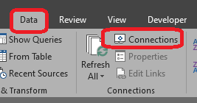
You may also reach out to me or the AFMC/FMC Data Analytics Team for assistance. You can contact the team via the General channel of the AFMC-FM Data Analytics Hub. This process could alternatively use Excel’s Data Model, Planner, Power BI, SharePoint, or Power Automate.
3. This is a tricky question without knowing more about your organization’s file needs and current “local server” capabilities. I’d be happy to discuss with you further if you would like. In the meantime, I will provide my opinion.
In my opinion, SharePoint would be a better option. This assumes that your “local server” functions much like the shared network drives. In the last organization I was in, we transitioned from the shared network drive to SharePoint. It took some effort but was worth it for us. The cloud provided us with more confidence in file integrity. Additionally, the cloud’s Version History and Recycle Bin protected us from accidental deletions. SharePoint is approved for IL5 and can store PII and CUI when access is properly controlled. Some details on this can be found here in PS-01. Since you can access SharePoint files via File Explorer, our users did not have as much of a learning curve as they thought they would.

