Mr. Hidalgo joined FTI in July 2018 as the Chief Financial Officer. He is a hands-on and strategic leader with a proven record of scaling businesses, ranging in size from $50M to multi-billion dollar, for rapid profits and growth. His proven leadership skills and discipline are creating and driving change at FTI to increase profitability, synergies, and team morale. His specific areas of expertise include strategic planning, change management, corporate structure, risk management, FP&A, accounting, and treasury.

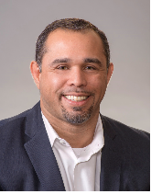

Mr. Hidalgo is a licensed CPA in the State of Virginia, and also holds the Certified Management Accountant (CMA) and the Certified Federal Contract Manager (CFCM) certifications. He received his Bachelors in Accounting from Strayer University, MBA from University of Maryland College Park- Robert H. Smith School of Business, and has completed numerous post graduate education from different Ivy League universities.

<https://www.fti-net.com/index.php/message-from-the-ceo/fti-management-team/jose-hidalgo/>